Low Level Design (Login Module)

Project Code | Team1
Project Name | Airline System

Prepared/Modified by | Role | Date of Preparation
Reviewed by | Role | Date of Review
Approved by | Role | Date of Approval
Vaishali S | Training Manager
Circulation List | Sanjay.sanjay@capgemini.com | Version Number of the template:1.0
Version Number | 1.4

Table of Contents

1. Description Of The Unit 3
2 References 4
3. Dependencies / Assumptions 5
4. Class Diagrams 6
5. Design Components 8
a. List Of UI Components 8
b. List Of Design Classes 9
6. Re-Usable Routines/Components 10
7. Messages 11
8. Configuration Files 12
9. Crud Matrix Table 13
10. Data Mapping Matrix 14
11. Action Flow Matrix 15
12. Stored Procedures 16
13. Program Specification / Pseudo Code 17
REVISION HISTORY OF THE WORK PRODUCT 19

Description Of The Unit

The login module allows the users of the application to login into the system using their valid credentials.

The userId and password entered by the user is validated from the database. If the entered credentials are valid then he/she is redirected to their respective pages based on their roles. Admin is redirected to Admin Page where options are provided to add or update a flight details. Executive is redirected to View Flight Occupancy Page where he/she can view all the details, view by date or view by status.Customer is redirected to Home Page where he/she can search, book the flight and cancel the booking.

If the entered credentials are invalid then he/she is redirected to the login page and an appropriate error message is displayed.

2 References

Reference | Description
Repository reference | https://github.com/intkhabahmed/ARS
Class Diagram | /Project Documents/Design Documents/HLD/Class Diagrams
URS | /Project Documents/Requirements/Case Study/Group-1-Airline Reservation System.doc
UTP | /Project Documents/Test Plan/UTP/Test Cases/Login Module/UTP_LoginModule.xls
DB Design | /Project Documents/Design Documents/HLD/DB Design/AirlineReservationSystem_GROUP_DBDESIGN.xls

Dependencies / Assumptions

Dependencies:
This module is dependent on the registration module wherein the user details are taken and stored in the database.

Assumptions:
UserId and password of the user are in the database. The customer details are stored in the database through registration module whereas admin/sales manager valid credentials are already exists in the database.

Class Diagrams

Class Diagram

Design Components

List Of UI Components

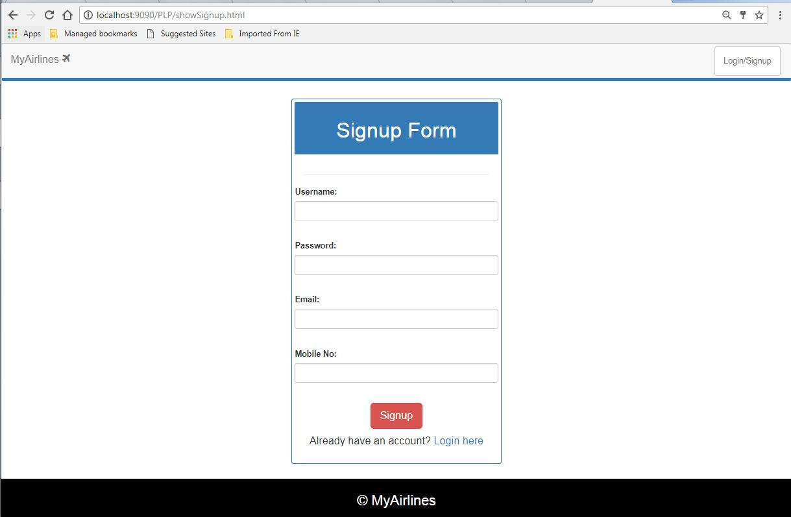

List Of Design Classes

Sr. No. | LLD Name | Class Name | Method Name | Method Description
1 | Login Module | User | Appropriate getters and setters methods | Getters retrieve the property values and setters set the property values
2 | Login Module | AirlineController | showLogin(Model model):String  loginValidation(  @ModelAttribute(ARSConstants.USER) User user,Model model, HttpServletRequest req):String  loginValidationAfterSearch(  @ModelAttribute(ARSConstants.USER) User user, Model model,HttpSession session):String | Sets the model attribute.  Calls validLogin () of AirlineServiceImpl class, which in turn calls validLogin() of AirlineDAOImpl and if user is present it redirects to appropriate Page.
3 | Login Module | AirlineServiceImpl | validLogin(user):User | Calls validLogin () of AirlineDAOImpl class and returns the result to controller.
4 | Login Module | AirlineDAOImpl | validLogin(user):User | Validates userId and password as per the database and returns the result to AirlineServiceImpl .

Re-Usable Routines/Components

Re-Usable Routines/Components

- CSS files
- Javascript files
- DataAccessException class
- Database properties files
- Logger properties files

Messages

#. | Type | Message Text
M1. | Error | Invalid Username/Password, Try Again
M2. | Error | Username is required
M3. | Error | Password is required

Configuration Files

File Name | Path | Description
Web.xml | /Development/source/ARS/WebContent/WEB-INF | To configure the bean properties.
ARSServlet-config.xml | /Development/source/ARS/WebContent/WEB-INF/config | To configure the request mapping and view resolver.
log4j.properties | /Development/source/ARS/resources | To configure the logger.
jpaContext.xml | /Development/source/ARS/resources | To datasource connection and autowired the bean.

Crud Matrix Table
# | Table Name | Create | Read | Update | Delete
1 | Users | N | Y | N | N

Data Mapping Matrix

Sr. No. | Screen Label | Field Source | Field Type | Data Type | Max Length | Data Flow | Mandatory
1 | Username | N/A | Label | N/A | N/A | UI | N/A
2 | username | User.username | TextBox | Varchar2 | 20 | UI→D | Yes
3 | Password | NA | Label | N/A | N/A | UI | N/A
4 | pwd | User.pwd | TextBox | Varchar2 | 20 | UI→D | Yes
5 | Login | N/A | Button | N/A | N/A | UI | N/A
6 | Forgot Password | N/A | Link | N/A | N/A | UI | N/A
7 | Sign Up | N/A | Link | N/A | N/A | UI | N/A

Legend

UI (User Interface Only)
UI → D (User Interface to Database)
D → UI (Database to User Interface)

Action Flow Matrix
Sr. No. | Action | Description | Process
1 | On click of Login Button | Valid User gets logged | UserId and Password is validated from the database. If user is valid he/she is directed to respective redirected to Home Page or Booking page if he/she is in between the booking process.

Stored Procedures

# | Stored Procedure Name  (with Description) | Input/Out Parameters | Type | Size
1. | NA | NA | NA | NA

Program Specification / Pseudo Code

14. 1 <ACTION: ONPAGE_LOAD>

Pseudo Code:

- Client Side Scripting
None
- Server Side Scripting

BEGIN
Call showLogin (Model model) in AirlineController class.
Navigates to Login Page.
END

14. 2 <ACTION: LOGIN_CLICK>

Pseudo Code:

- Client Side Scripting:

IF Username isEmpty
Print Error Message M2
IF Password isEmpty
Print Error Message M3
IF invalid Username
Print Error Message M1
IF invalid Password
Print Error Message M1
IF length of Username > 20 characters
Print Error Message M1
IF length of Password > 20 characters
Print Error Message M1

Server Side Scripting:
- 1. If user direct login
BEGIN
String loginValidation(@ModelAttribute(ARSConstants.USER) User user,Model model, HttpServletRequest req) in AirlineController class in Presentation Layer
BEGIN
Call validLogin(User user) in AirlineServiceImpl class in Service Layer
BEGIN
Call validLogin (User user) in AirlineDAOImpl class in Service Layer
BEGIN
Create query to search if the user exists or not
END
Return user to AirlineServiceImpl
END
Return user to AirlineDAOImpl class
END
Navigate to home page.
END

- 2. If user login after select a flight for book
BEGIN
loginValidationAfterSearch(@ModelAttribute(ARSConstants.USER) User user, Model model,HttpSession session)
BEGIN
Call validLogin(User user) in AirlineServiceImpl class in Service Layer
BEGIN
Call validLogin (User user) in AirlineDAOImpl class in Service Layer
BEGIN
Create query to search if the user exists or not
END
Return user to AirlineServiceImpl
END
Return user to AirlineDAOImpl class
END
Navigate to booking confirm page.
END

REVISION HISTORY OF THE WORK PRODUCT
# | Date | Version # | Section Changed | Details of changes made | Approved By
1 | 7/11/2017 | 1.0 | Document prepared | N/A | Vaishali Srivastava
2 | 11/11/2017 | 1.1 | List of design classes  Data Mapping Matrix | The controller’s name is changed to “EshopController”  Change Password field added | Vaishali Srivastava
3 | 11/11/2017 | 1.2 | Reusable components,  References,  Data Mapping Matrix. | Reusable Components added.  File name with relative path is added in the references section.  The name of text boxes(screen label is changed). | Vaishali Srivastava
4 | 11/11/2017 | 1.3 | Messages | Changes made in Error Messages | Vaishali Srivastava
5 | 11/11/2017 | 1.4 | Configuration files,UI Components | Paths of the configuration files is updated and UI components(Screen Shots) added. | Vaishali Srivastava

